Model Optimization and Tuning Phase Report

|  |  |
| --- | --- |
| Date | 15 july 2024 |
| Team ID | 740017 |
| Project Title | Unveiling baldness: Genetic and environmental dynamics |
| Maximum Marks | 10 Marks |

# Model Optimization and Tuning Phase

The Model Optimization and Tuning Phase involves refining machine learning models for peak performance. It includes optimized model code, fine-tuning hyperparameters, comparing performance metrics, and justifying the final model selection for enhanced predictive accuracy and efficiency.

# Hyperparameter Tuning Documentation (6 Marks):

|  |  |  |
| --- | --- | --- |
| **Model** | **Tuned Hyperparameters** | **Optimal Values** |
| Decision Tree | ------ | ----- |

|  |  |  |
| --- | --- | --- |
| Logistic  Regression | ----- | ------ |
| Ada  Boost | -------- | ------ |
| Random Forest | ----- | ---- |

**Performance Metrics Comparison Report (2 Marks):**

**Optimized Metric**

**Model**

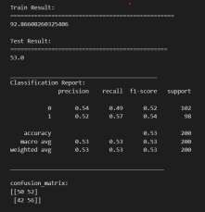

Decision Tree

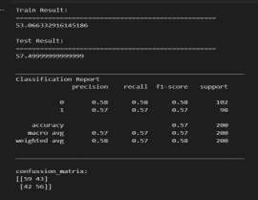

Logistic

Regression

|  |  |
| --- | --- |
| KNN | ------- |
| Ada Boosting | ----- |

|  |  |
| --- | --- |
| Support vector machine | ------- |

# Final Model Selection Justification (2 Marks):

|  |  |
| --- | --- |
| **Final Model** | **Reasoning** |
| Support vector machine | The Support vector machine was selected for its superior performance exhibiting . Its ability to handle complex relationships, minimize overfitting, and optimize predictive accuracy aligns with project objectives, justifying its selection as the final model. |